SPAV-international journal of planning and arhitectural science
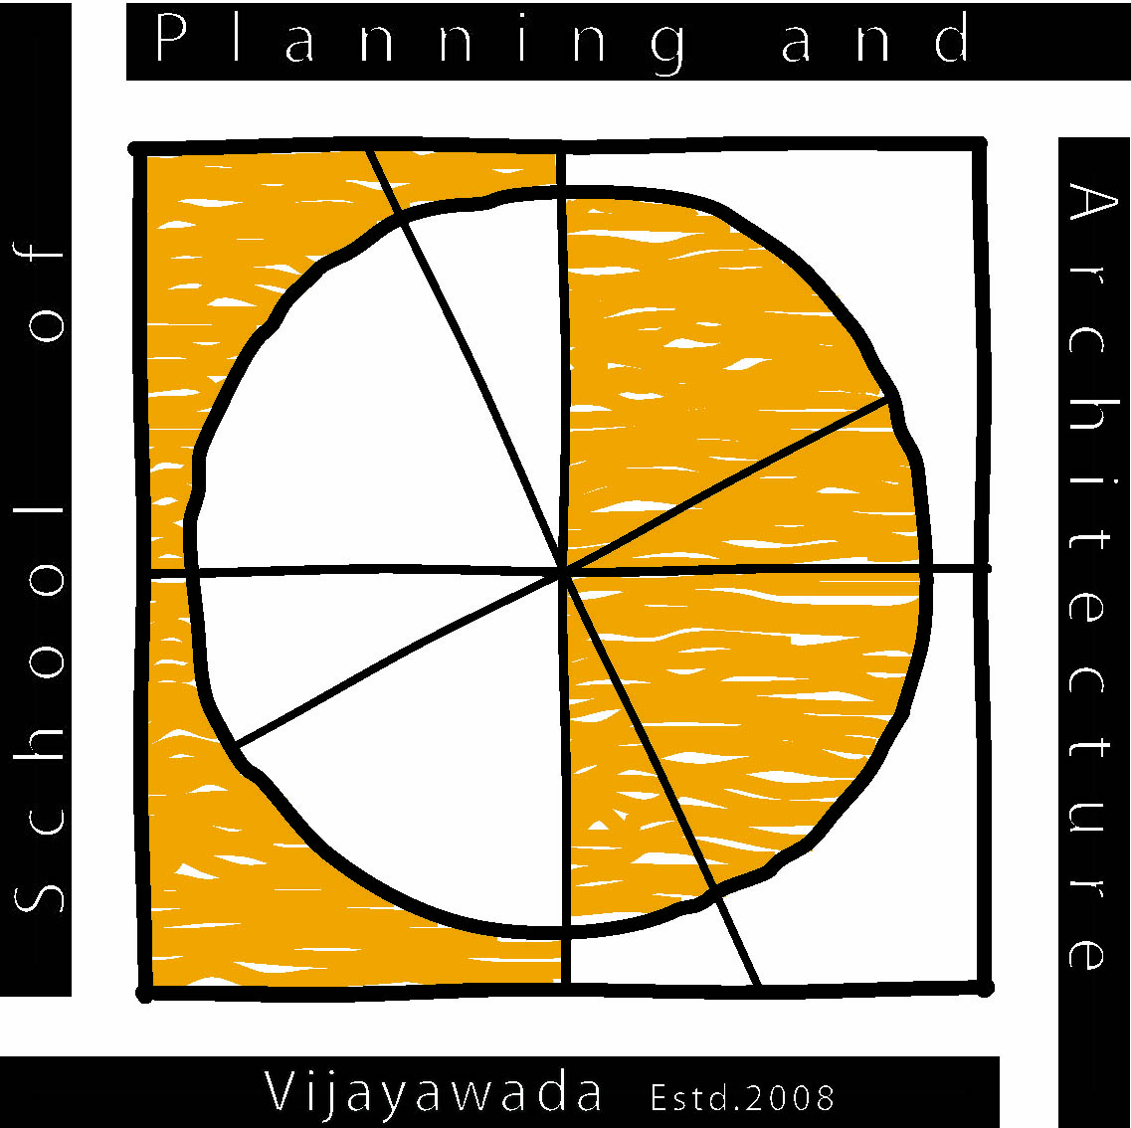
SPAV-International Journal of Planning and Architectural Science (SPAV-IJPAS)

Volume No. 1. Issue No. 1

Type the Title of Your Paper, Capitalize First Letter
First Author^{a*}, Seccond Author^{b}, Third Author^{ab}
ª First author’s affiliation, Email ID
^{b} Second author’s affiliation, Email ID
* Corresponding author

Abstract
Insert you text here (Max of 250 words)

Keywords:

1. INRODUCTION
Here introduce the paper, and put a nomenclature if necessary in a box with the same font size as the rest of the paper. The paragraphs continue from here and are only separated by headings, subheadings, images and formulae. The section headings are arranged by numbers, bold and 12 pt. Here follows further instructions for authors.

1.1 Structure
Follow this indicative order when typing manuscripts: Title, Authors, Affiliations, Abstract, Keywords, Main text (including figures and tables), Acknowledgements, References, Appendix. Files must be in MS Word only and should be formatted as per the instructions provided. Figures and tables should be embedded and not supplied separately. Please do not alter the formatting and style layouts which have been set up in this template document

1.2 Section Headings
Section headings should be left justified, bold, with the first letter capitalized and numbered consecutively, starting with the Introduction. Sub-section headings should be in capital and lower-case italic letters, numbered 1.1, 1.2, etc, and left justified.
1.3 Tables
All tables should be numbered with Arabic numerals. Every table should have a caption. Headings should be placed above tables, center aligned. Only horizontal lines should be used within a table as shown in Table 1. Tables must be embedded into the text and not supplied separately.

Table 1: An example of an indicative table
An example of a column heading | Column A (t) | Column B (t)
And an entry | 1 | 2
And another entry | 3 | 4
And another entry | 5 | 6

1.4 Figures or Illustrations
All figures should be numbered with Arabic numerals (1,2,3,….). Every figure should have a caption as shown in Figure 1. All photographs, schemas, graphs and diagrams are to be referred to as figures. Figures must be embedded into the text and not supplied separately. Preferred format of figures are PNG, JPEG, GIF etc. Lettering and symbols should be clearly defined either in the caption or in a legend provided as part of the figure. Please ensure that all the figures are of 300 DPI resolutions as this will facilitate good output.

Figure 1: Indicative figure for illustration.

1.5 References and Citation
References must be listed at the end of the paper. Do not begin them on a new page unless this is absolutely necessary. Authors should ensure that every citation in the text appears in the list of references and vice versa. Use APA style for referencing and citation.

